**Warehouse**

**LIST OF PROCEDURES and RULES**

**Changes to tables:**

1. **Alter Table Activity – add Cycle ID**
2. **ADD:**

|  |  |  |  |
| --- | --- | --- | --- |
| Transaction Type - NEW | |  |  |
| PK | TypeID |  |  |
|  | TransactionType | text |  |

|  |  |
| --- | --- |
| TransactionType (populated) NEW |  |
| 01 | Withdrawal |
| 02 | Return |
| 03 | Adjustment |

|  |  |  |  |
| --- | --- | --- | --- |
| Transactions – (replaces Withdrawals) | |  |  |
| PK | TransactionID |  |  |
|  | TransactionType | FK |  |
|  | ActivityID | FK |  |
|  | DepositID | FK |  |
|  | Quantity |  | real |
|  | Date |  | date |
|  | HR_ID(who made the transaction) |  | FK |
|  | Justification |  | text |

|  |  |  |  |  |  |  |  |  |
| --- | --- | --- | --- | --- | --- | --- | --- | --- |
| Deposits - NEW | | | | |  | |  | |
| PK | | | IDdeposit | |  | |  | |
|  | | | Date&time | |  | | date | |
|  | | | IDmaterial | | FK | |  | |
|  | | | Initial Quantity | |  | | real | |
|  | | | Actual Quantity (derived value) | |  | | real | |
|  | | | Total Cost | |  | | real | |
|  | | | Experation Date | |  | | date | |
|  | | | location | |  | | text | |
|  | | | Unit Type | | FK | |  | |
|  | | | IDPurchase Invoice | | FK | |  | |
|  | | | IDfarm | | FK | |  | |
|  | | | quality certificate location/link | |  | | text | |
|  | | |  | |  | |  | |
| CYCLE | | |  | |  | |
| PK | Cycle_ID | |  | |  | |
| PK | IDcrop | | FK | |  | |
|  | IDactivityName | | FK | |  | |
|  | HR required | |  | | Boolean | |
|  | Machine required | |  | | Boolean | |
|  | Service required | |  | | Boolean | |
|  | Materials required | |  | | Boolean | |
|  | Cycle number | |  | | smallint | |
|  | Initial Date | |  | | Date | |
|  | Final Date | |  | | Date | |
|  | Cost of HR Budget | |  | | real | |
|  | Cost of HR Actual | |  | | real | |
|  | Cost of Machines Eq. Budget | |  | | real | |
|  | Cost of Machines Eq. Actual | |  | | real | |
|  | Cost of Services Budget | |  | | real | |
|  | Cost of Service Actual | |  | | real | |
|  | Cost of Materials Budget | |  | | real | |
|  | Cost of Materials Actual | |  | | real | |

**Planning**

Background: Prior to performing any activity that requires material purchases initial planning takes place. During planning stage, Planner evaluates materials at hand in the warehouse (left form previous cycles) and estimates quantities needed. Quantities and quotes for materials purchases and services are gathered. Quotes get approved and used to purchase more materials and/or hire services.

Under this scenario, budgeting takes place at CYCLE level (cycle has been defined as a set of repeating activity that continues until the purpose is served). In order to keep track of daily events, HR time and warehouse activity transactions related to Warehouse are recorded at the activity level (activity is confined to a single day). Summing up transactions from set of cycle related activities will create actual values and costs. This approach also allows using activity budget for planning only.

Quantity availability will then have to consider available quantity of the deposits and previously budgeted ones.

For example:

Let’s assume that material A is used by two different crops. The total quantity remaining in the warehouse is X . When activity N budgets for $a_{n}$ quantities of the material all other budgeted quantities of parallel activities should be considered to estimate the sufficiency. Thus to know if there is enough to fulfill the need, $a_{n}$ has to be

$a_{n}$ < = X - ${ (a}_{(n-1) }$ + ${ (a}_{(n-2) }+…$)

where ${ a}_{(n-1) }$ is quantity budgeted **but not distributed**. Only budgeted values that don’t have matching “actuals” be considered for this estimation. This is only needed to avoid budgeting for quantities that can’t be fulfilled. In other words, this is just to validate quantities in the warehouse and prevent “over-booking”.

***Planning User Case:***

User logs into the system and creates new CYCLE:

1. User selects CROP (required field) from drop down menu.

2. User selects Cycle type (required field - named after main activity to be performed).

3. User defines Cycle Initial and Final dates. (Required fields- but can be changed later- not immutable entry)

4. User estimates budget values of Materials, HR, Machinery and Service Quotes (from previous cycles or by plantation size)

Deposit Use Case:

When materials are purchased they are entered into Warehouse and deposit is registered.

User has to enter data into following required fields:

***Material*** - Material Type can be selected first to narrow down materials registered in the system. “ALL” option exist as well

***Quantity***

***Total cost***

***Expiration Date*** - if exists

***Purchase Invoice*** - from list of existing invoices

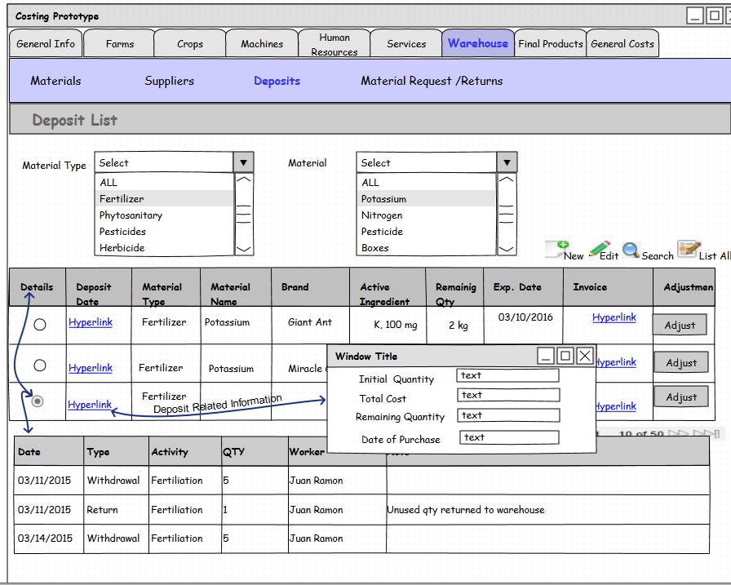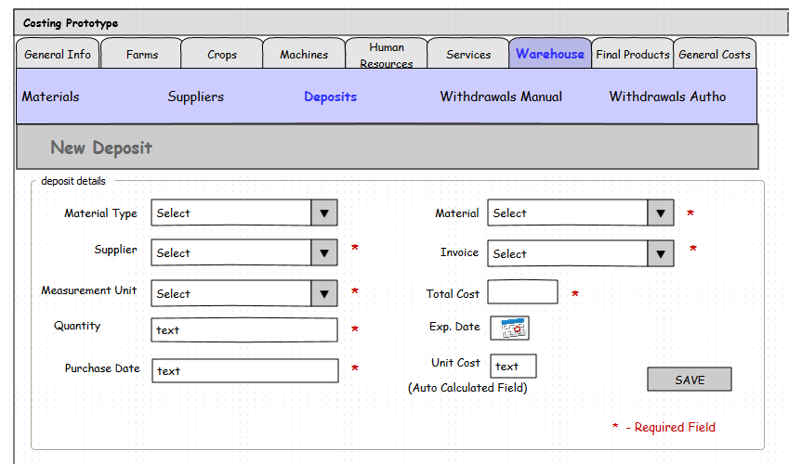

**\*At the time of deposit recording DEPOSITS.quantity actual is set to DEPOSITS.initial quantity**

Now, that Activity Cycle is registered

1. Actuals will be equal to (Transaction. Quantity for Transaction. Type= 01(withdrawal) - Transaction. Quantity for Transaction. Type= 02(Return)

Each time materials are withdrawn from the warehouse new transaction of “Withdrawn” type is entered into Transaction table. It has Quantity, Activity Id, and Deposit ID.

System distributes materials **in FIFO order** (date of purchase is earliest) by making sure

If single deposit is not enough to satisfy the quantities for daily activity Transaction table will have additional Withdrawal records with same Activity Id, corresponding Deposit Id, and additional Quantities. Actual Quantities will be adjusted for both deposits: First one showing “0” available and second amount deducted.

In case, that not all quantities have been used user should register return to the warehouse and **Transaction of “Return”** type will appear in the “Transaction “Table. It will enter quantity back to the deposit. To identify deposit system pulls all the Deposits ID linked to Activity ID and applies to deposit in the LIFO order (latter deposit of two gets its quantities back by adjusting actual quantity). If more than one **Deposit** gets quantities back then system should register two or more **“Return” Transactions**.

Adjustments to **W300 Withdrawal**

User selects the crop and the specific activity, and creates a **Transaction of Withdrawal type**.

1. System registers: Transaction. ActivityId, Transaction.Quantity, Transaction.Deposit_ID Transaction.Type= 01(Withdrawal). If more than one deposit is required to satisfy the request for quantities then appropriate number of transactions of withdrawal type will be entered into the system.

***For example***: User requests 10 units of materials. In FIFO order System Identifies two deposits each having 6 and 20 unit. System registers two withdrawal transactions: for 6 units from “older” deposit and 4 from more recent one. Each deposit has “Actual Quantity” adjusted: to “0” and to (20-4) = 16 units accordingly.

If the is not enough quantities in the deposits: (Quantity Requested from user side > sum of DEPOSITS. quantity actual), emit a WARNING asking to verify the deposits before creating a withdrawal

1. In case of unused quantities, user can perform return to Warehouse.

User should specify activity (not a CYCLE) to register return. System queries the Transaction table for matching Withdrawals to identify related Deposits. System registers Transaction Type =”Return”, DepositID (in LIFO) order, Activity ID, and adjust quantities available in the Deposit.

* If more than one **Deposit** gets quantities back then system should register two or more **“Return” Transactions**.

1. The system calculates **Activity**.**Cost of Materials Budget** as Sum (Transaction.Quantity * (Depost.Cost /Deposit.InitialQuantity) ) with matching Activity Id

where Transaction.Type= **Withdrawal**

1. If User reports that Materials we used as budgeted then it becomes **Activity**.**Cost of Materials Actual.** In case of return, Sum of (Transaction.Quantity * (Depost.Cost /Deposit.InitialQuantity)) with matching Activity Id Where Transaction.Type= **Return** is subtracted from **Activity**.**Cost of Materials Budget** and becomes **Activity**.**Cost of Materials Actual.**
2. In reality, additional adjustment may be needed to register losses, damages and expired materials. These can’t be allocated to any activity and should be accounted for as overhead:

To reconsolidate: Deposit. Quantity Actual = Initial Quantity +Sum(Returns) –Sum(Withdrawals) - Sum ( Adjustments).

***Activity Cycle Cost :***

Activity Cycle Cost consists of HR (Labor) Cost, Materials Cost, Services Cost (if applicable) and Machine Cost.

To evaluate budget cost of Materials user have to enter estimate for materials quotes.

Once Cycle is complete, user runs “Calculate Cycle Costs” procedure that adds up all the Actual Material Cost, Actual HR cost , Actual Machine Cost values from co-named activities that occurred during Cycle dates (Initial and Final dates). This becomes necessary due to the fact that most of the processes on plantation last for multiple days including those solely performed by external services. To comply with UTZ requirement of HR overtime tracking and translucency daily activity had to be confined to same calendar day. The cost of daily activity is not as interesting to management as the entire cycle is. Thus said, Budget and Actual cost had to be calculated on the Cycle level and be modified to create value to potential user.